**Acropolis Institute Of Technology And Research,**

**Indore (M.P.)**

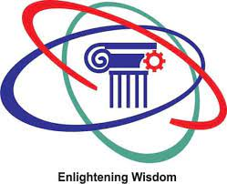

**Subject – Database Management System (DBMS)**

**(CY-405)**

**Name – Rishita Jain**

**Enrollment No. – 0827CY221050**

**Branch - CS(Cyber Security)**

**Semester - 4th  (2nd year)**

**Submitted To – Mrs. Nidhi Nigam Ma’am**

**Index**

|  |  |  |  |  |
| --- | --- | --- | --- | --- |
| **Sr. No.** | **Experiment** | **Date of Exp.** | **Date of sub.** | **Grade** |
| 1. | To study DBMS and RDBMS, its characteristic comparisons and study of popular DB software. | 11/03/24 | 18/03/24 |  |
|  |  |  |  |  |
|  |  |  |  |  |
|  |  |  |  |  |
|  |  |  |  |  |
|  |  |  |  |  |
|  |  |  |  |  |
|  |  |  |  |  |
|  |  |  |  |  |
|  |  |  |  |  |
|  |  |  |  |  |
|  |  |  |  |  |

Lab work 1

Introduction to Database, Comparitive Study of DBMS & RDBMS, STUDY OF LATEST SOFTWARES OF DBMS

What is DBMS ?

Database Management Systems (DBMS) are software systems used to store, retrieve, and run queries on data. A DBMS serves as an interface between an end-user and a database, allowing users to create, read, update, and delete data in the database.

## Key Features of DBMS

* **Data modeling:** A DBMS provides tools for creating and modifying data models, which define the structure and relationships of the data in a database.
* **Data storage and retrieval:** A DBMS is responsible for storing and retrieving data from the database, and can provide various methods for searching and querying the data.
* **Concurrency control:** A DBMS provides mechanisms for controlling concurrent access to the database, to ensure that multiple users can access the data without conflicting with each other.
* **Data integrity and security:** A DBMS provides tools for enforcing data integrity and security constraints, such as constraints on the values of data and access controls that restrict who can access the data.
* **Backup and recovery:** A DBMS provides mechanisms for backing up and recovering the data in the event of a system failure.
* **DBMS can be classified into two types:** Relational Database Management System (RDBMS) and Non-Relational Database Management System (NoSQL or Non-SQL)
* **RDBMS:** Data is organized in the form of tables and each table has a set of rows and columns. The data are related to each other through primary and foreign keys.
* **NoSQL:** Data is organized in the form of key-value pairs, documents, graphs, or column-based. These are designed to handle large-scale, high-performance scenarios.

## Applications of DBMS

* **Enterprise Information:** Sales, accounting, human resources, Manufacturing, online retailers.
* **Banking and Finance Sector:** Banks maintaining the customer details, accounts, loans, banking transactions, credit card transactions. Finance: Storing the information about sales and holdings, purchasing of financial stocks and bonds.
* **University:** Maintaining the information about student course enrolled information, student grades, staff roles.
* **Airlines:** Reservations and schedules.
* **Telecommunications:** Prepaid, postpaid bills maintance.

TYPES OF DBMS

There are various types of databases used for storing different varieties of data:

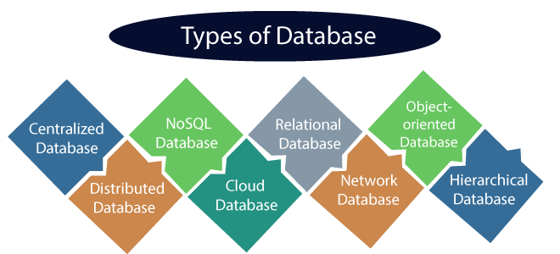

## 1) Centralized Database

It is the type of database that stores data at a centralized database system. It comforts the users to access the stored data from different locations through several applications. These applications contain the authentication process to let users access data securely. An example of a Centralized database can be Central Library that carries a central database of each library in a college/university.

## 2) Distributed Database

Unlike a centralized database system, in distributed systems, data is distributed among different database systems of an organization. These database systems are connected via communication links. Such links help the end-users to access the data easily. **Examples** of the Distributed database are Apache Cassandra, HBase, Ignite, etc.

## 3) Relational Database

This database is based on the relational data model, which stores data in the form of rows(tuple) and columns(attributes), and together forms a table(relation). A relational database uses SQL for storing, manipulating, as well as maintaining the data. E.F. Codd invented the database in 1970. Each table in the database carries a key that makes the data unique from others. **Examples** of Relational databases are MySQL, Microsoft SQL Server, Oracle, etc.

## 4) NoSQL Database

Non-SQL/Not Only SQL is a type of database that is used for storing a wide range of data sets. It is not a relational database as it stores data not only in tabular form but in several different ways. It came into existence when the demand for building modern applications increased. Thus, NoSQL presented a wide variety of database technologies in response to the demands. We can further divide a NoSQL database into the following four types:

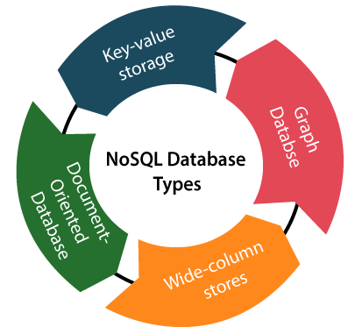

## 5) Cloud Database

A type of database where data is stored in a virtual environment and executes over the cloud computing platform. It provides users with various cloud computing services (SaaS, PaaS, IaaS, etc.) for accessing the database. There are numerous cloud platforms, but the best options are:

* Amazon Web Services(AWS)
* Microsoft Azure
* Kamatera
* PhonixNAP
* ScienceSoft
* Google Cloud SQL, etc.

## 6) Object-oriented Databases

The type of database that uses the object-based data model approach for storing data in the database system. The data is represented and stored as objects which are similar to the objects used in the object-oriented programming language.

## 7) Hierarchical Databases

It is the type of database that stores data in the form of parent-children relationship nodes. Here, it organizes data in a tree-like structure.

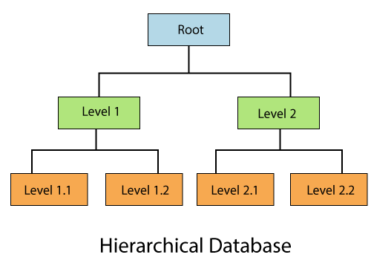

Data get stored in the form of records that are connected via links. Each child record in the tree will contain only one parent. On the other hand, each parent record can have multiple child records.

## 8) Network Databases

It is the database that typically follows the network data model. Here, the representation of data is in the form of nodes connected via links between them. Unlike the hierarchical database, it allows each record to have multiple children and parent nodes to form a generalized graph structure.

EXAMPLE OF DBMS:

1. Oracle Database

### 2. MySQL Database

### 3. PostgreSQL Database

### 4. MongoDB

### 5. MS Access

### 6. Microsoft SQL Server and so on ......

**What is MYSQL?**

MySQL is the world’s most popular open source database. According to [DB-Engines](https://db-engines.com/en/ranking), MySQL ranks as the second-most-popular database, behind [Oracle Database](https://www.oracle.com/in/database/). MySQL powers many of the most accessed applications, including Facebook, Twitter, Netflix, Uber, Airbnb, Shopify, and Booking.com.

Since MySQL is open source, it includes numerous features developed in close cooperation with users over more than 25 years. So it’s very likely that your favorite application or programming language is supported by MySQL Database.

### **How do you pronounce “MySQL”?**

“My ess-cue-el” is the “official” way to pronounce “MySQL,” but pronouncing it “my sequel” is common too.

## **MySQL is a relational database management system**

[Databases](https://www.oracle.com/in/database/what-is-database/) are the essential data repository for all software applications. For example, whenever someone conducts a web search, logs in to an account, or completes a transaction, a database system is storing the information so it can be accessed in the future.

A [relational database](https://www.oracle.com/in/database/what-is-a-relational-database/) stores data in separate tables rather than putting all the data in one big storeroom. The database structure is organized into physical files optimized for speed. The logical data model, with objects such as data tables, views, rows, and columns, offers a flexible programming environment. You set up rules governing the relationships between different data fields, such as one to one, one to many, unique, required, or optional, and “pointers” between different tables. The database enforces these rules so that with a well-designed database your application never sees data that’s inconsistent, duplicated, orphaned, out of date, or missing.

The “SQL” part of “MySQL” stands for “Structured Query Language.” SQL is the most common standardized language used to access databases. Depending on your programming environment, you might enter SQL directly (for example, to generate reports), embed SQL statements into code written in another language, or use a language-specific API that hides the SQL syntax.

## **MySQL works in client/server or embedded systems:**

MySQL Database is a client/server system that consists of a multithreaded SQL server that supports different back ends, several different client programs and libraries, administrative tools, and a wide range of application-programming interfaces (APIs). We also provide MySQL as an embedded multithreaded library that you can link into your application to get a smaller, faster, easier-to-manage standalone product.

IS MYSQL IS OPEN SOURCE ?

[Open source](https://developer.oracle.com/open-source/what-is-open-source/) means it’s possible for anyone to use and modify the software. Anybody can download MySQL software from the internet and use it without paying for it. You can also change its source code to suit your needs. MySQL software uses the [GNU General Public License](http://www.fsf.org/licenses/) (GPL) to define what you may and may not do with the software in different situations.

If you feel uncomfortable with the GNU GPL or need to embed MySQL code into a commercial application, you can buy a commercially licensed version from Oracle. See the [MySQL Licensing Information section](https://www.mysql.com/about/legal/) for more information.

**MySQL benefits:**

MySQL’s key benefits include

**Ease of use:** Developers can install MySQL in minutes, and the database is easy to manage.

**Reliability:** MySQL is one of the most mature and widely used databases. It has been tested in a wide variety of scenarios for more than 25 years, including by many of the world’s largest companies. Organizations depend on MySQL to run business-critical applications because of its reliability.

**Scalability:** MySQL scales to meet the demands of the most accessed applications. MySQL’s native replication architecture enables organizations such as Facebook to scale applications to support billions of users.

**Performance:** MySQL HeatWave is faster and less expensive as demonstrated by multiple standard industry benchmarks, including TPC-H, TPC-DS, and CH-benCHmark

**High availability:** MySQL delivers a complete set of native, fully integrated replication technologies for high availability and disaster recovery. For business-critical applications, and to meet service-level agreement commitments, customers can achieve

* Recovery point objective = 0 (zero data loss)
* Recovery time objective = seconds (automatic failover)

**Security:** [Data security](https://www.oracle.com/in/security/database-security/what-is-data-security/) entails protection and compliance with industry and government regulations, including the European Union General Data Protection Regulation, the Payment Card Industry Data Security Standard, the Health Insurance Portability and Accountability Act, and the Defense Information Systems Agency’s Security Technical Implementation Guides. MySQL Enterprise Edition provides advanced security features, including authentication/authorization, transparent data encryption, auditing, data masking, and a database firewall.

**Flexibility:** The MySQL Document Store gives users maximum flexibility in developing traditional SQL and NoSQL schema-free database applications. Developers can mix and match relational data and JSON documents in the same database and application.

DIFFERENCE BETWEEN DBMS AND RDBMS

|  |  |
| --- | --- |
| **DBMS** | **RDBMS** |
| 1.Data is stored in a database management system (DBMS) as a file | Tables are used to store information |
| 2.Data is stored in a database management system (DBMS) in either a navigational or hierarchical format | RDBMS employs a tabular format, with column names as headers and associated data as rows |
| 3.Only a single user is supported by the DBMS | It may be used by numerous people |
| 4.The data in a typical database may not be stored according to the ACID model  5.This can lead to database discrepancies | Relational databases are more difficult to create, but they are more consistent and organised  They follow the rules of ACID (Atomicity, Consistency, Isolation, Durability) |
| 6.It is an application that is used to manage databases over computer networks as well as the system hard drives | The database systems are used to keep track of the relationships between the tables |
| 7.Software and hardware requirements are minimal | Higher hardware and software requirements are required |
| 8.The integrity constraints are not supported by DBMS  At the file level, the integrity constraints are not imposed | At the schema level, RDBMS provides integrity restrictions  Values outside of a certain range cannot be stored in the RDBMS column |
| 9.Normalization is not supported by DBMS. | A relational database management system (RDBMS) can be normalised. |
| 10.Distributed databases are not supported by DBMS | Distributed databases are supported by RBMS |
| 11.The DBMS system is mostly used to manage tiny amounts of data | The RDBMS database is built to manage a vast volume of data |
| 12.Dbms only meet seven of Dr E.F. Codd’s rules | Dbms meet 8 to 10 of Dr E.F. Codd’s rules |
| 13.Client-server architecture is not supported by DBMS | Client-server architecture is supported by RDBMS |
| 14.For complicated and vast amounts of data, data retrieval takes longer | Because of its relational methodology, data retrieval is quick |
| 15.In this architecture, data redundancy is common | Data redundancy is not possible using keys and indexes |
| 16.There is no correlation between the data | Data is kept in the form of tables that are linked together via foreign keys |
| 17.There is no sense of safety | Multiple security levels are available. At the OS, command, and object levels, log files are produced |
| 18.Individual data items must be accessed | SQL queries make it simple to retrieve data  At the same time, many data items can be accessed |
| 19.A file system, XML, the Windows Registry, and other DBMS are examples | MySQL, Oracle, SQL Server, and other RDBMS are examples |